Date: ____________
Practical No. 01
Aim: a) Write a python program to Collect data from a real-life business scenario and perform exploratory data analysis (EDA) to gain insights into the dataset.
b) Aim: Write a python program to Analyze customer data to identify trends and patterns that can be used for business decision-making.
INPUT:
import pandas as pd
# Supermarket sales data
data = {
'Product': ['Mobile', 'Laptop', 'Rice', 'Shirt', 'Mobile'],
'Category': ['Electronics', 'Electronics', 'Groceries', 'Clothing', 'Electronics'], 'Sales': [15000, 45000, 3000, 2000, 18000]
}
# Create DataFrame
df = pd.DataFrame(data)
# Display data
print("Dataset:")
print(df)
# Total sales
print("\nTotal Sales =", df['Sales'].sum())
# Category-wise sales
print("\nSales by Category:")
print(df.groupby('Category')['Sales'].sum())
# Statistical summary
print("\nStatistics:")
print(df['Sales'].describe())
OUTPUT:
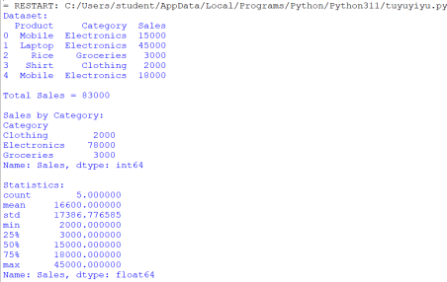
Insights from EDA
1. Total Revenue: ₹83,000.
2. Average Sale per Product: ₹16,600.
3. Best-Selling Category: Electronics (₹78,000).
4. Lowest-Selling Category: Clothing (₹2,000).
5. The supermarket should focus on Electronics products and increase promotions for Clothing and Groceries.
Conclusion
Exploratory Data Analysis (EDA) helps businesses understand sales trends and customer preferences. From this analysis, Electronics is the most profitable category, contributing the majority of the supermarket's revenue.
b) Analyze customer data to identify trends and patterns that can be used for business decision-making.
INPUT:
import pandas as pd
# Customer data
data = {
'Customer': ['A', 'B', 'C', 'D', 'E'],
'Age': [22, 35, 28, 45, 30],
'Purchase': [5000, 12000, 8000, 15000, 10000]
}
df = pd.DataFrame(data)
print("Customer Data:")
print(df)
print("\nAverage Age =", df['Age'].mean())
print("Average Purchase =", df['Purchase'].mean())
print("\nHighest Purchase Customer:")
print(df.loc[df['Purchase'].idxmax()])
OUTPUT:
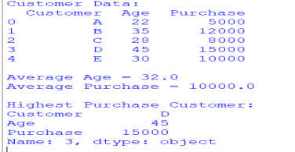
Trends and Patterns Identified
1. Age Group Trend
Customers between 30 and 45 years tend to spend more than younger customers. 2. Spending Pattern
The average spending is ₹10,000, while the highest spender purchased goods worth ₹15,000. 3. Valuable Customers
Customer D is a high-value customer and may be targeted with special offers or loyalty programs.
Conclusion
This analysis shows that the average customer age is 32 years, the average purchase amount is ₹10,000, and Customer D is the highest spender. These insights help businesses understand customer behavior and make better marketing and sales decisions.

